Task 2
- Installation maven in windows
Step 1: Download the mvn
https://dlcdn.apache.org/maven/maven-3/3.9.9/binaries/apache-maven-3.9.9-bin.zip
Step 2: Extract the files in a path
C:\Program Files
Step 3: a. go to environmental variables
b. select the path option in system variables and click edit
c. add new path
C:\Program Files\apache-maven-3.9.9\bin
d. add new path in the user variables for admin
C:\Program Files\apache-maven-3.9.9
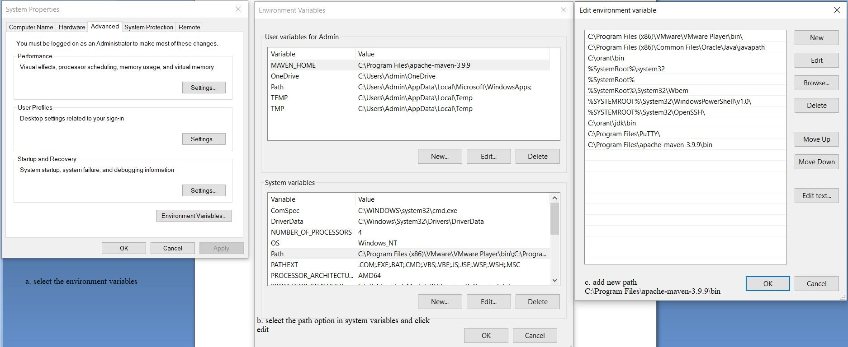

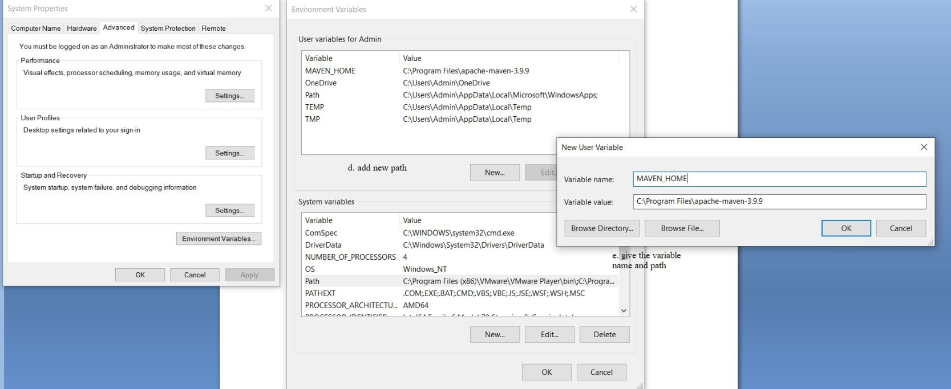

Step 4: open a command prompt and check the version of maven
mvn –version

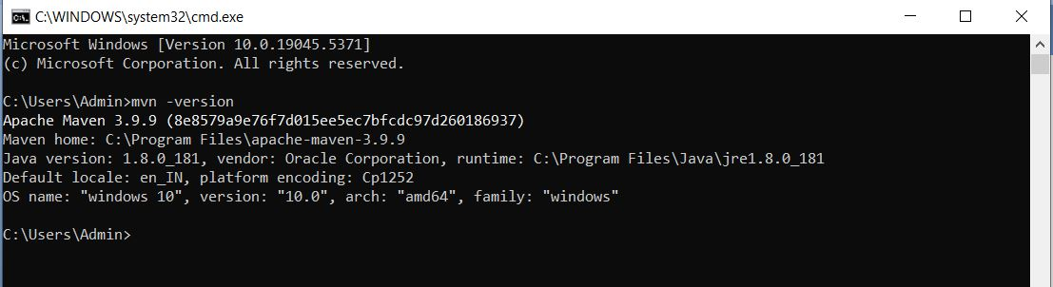

- Man Mvn
The command mvn refers to Apache Maven, which is a build automation tool primarily used for Java projects. When you type man mvn in a terminal, it would typically open the manual (man) page for the mvn command if you're on a Unix-like operating system (e.g., Linux, macOS), but unfortunately, mvn doesn’t have a man page by default. Instead, the usage and options for mvn are documented on the official website and in other places.
To understand what the mvn command does, here's a general overview:

Maven (mvn) Overview
Maven is used to manage Java projects, including tasks such as:
- Building: Compiling source code, packaging the code into JARs/WARs, etc.
- Dependencies: Managing libraries that your project depends on.
- Project Configuration: Using a pom.xml file, Maven handles various project configurations like source code directories, plugins, and versions.
- Running Tests: Executing unit tests.
- Deploying: Deploying to remote repositories or servers.

Common mvn Commands
- mvn clean
Cleans the project by deleting the target/ directory, which contains compiled files and other generated files.
mvn clean
- mvn compile
Compiles the source code of the project.
mvn compile
- mvn test
Runs the unit tests for the project (using the test phase in the build lifecycle).
mvn test
- mvn package
Packages the compiled code into a JAR/WAR file.
mvn package
- mvn install
Installs the packaged JAR/WAR into the local Maven repository (~/.m2/repository), making it available for other projects.
mvn install
- mvn deploy
Deploys the artifact (JAR/WAR) to a remote repository for sharing with others.
mvn deploy
- mvn clean install
A combination of mvn clean and mvn install — first cleans the project and then installs the package.
mvn clean install
- mvn validate
Validates the project setup and checks if all configurations are correct.
mvn validate
- mvn site
Generates a site for the project, including reports about code quality, tests, etc.
mvn site

How to Get Help on mvn
You can always get a list of available commands and options by typing:
mvn --help
This will show you the available options and details about how to use the mvn command.

Summary
- mvn is the command-line interface to Apache Maven.
- It's used for building, testing, packaging, and deploying Java projects.
- You typically manage Maven with a pom.xml configuration file, which specifies project dependencies, plugins, and build settings.

